What is an adjustment?
By Robert A. Leach, DC, MS, CHES, FICC

Doctors of Chiropractic use their hands or a small instrument to attempt to improve joint alignment or function.

Perhaps you have heard someone “pop” their knuckles or other joints. This doesn’t hurt and usually feels good, otherwise they wouldn’t continue to do this. Scientists determined that the “popping” sound is actually carbon dioxide gas leaving the joint capsule. After the “pop” is heard there is a “refractory” period that lasts from 45 to 90 minutes during which you cannot “pop” the joint again. During the refractory period new circulation including “happy chemicals” that fight inflammation, and carbon dioxide gas return to the joint.

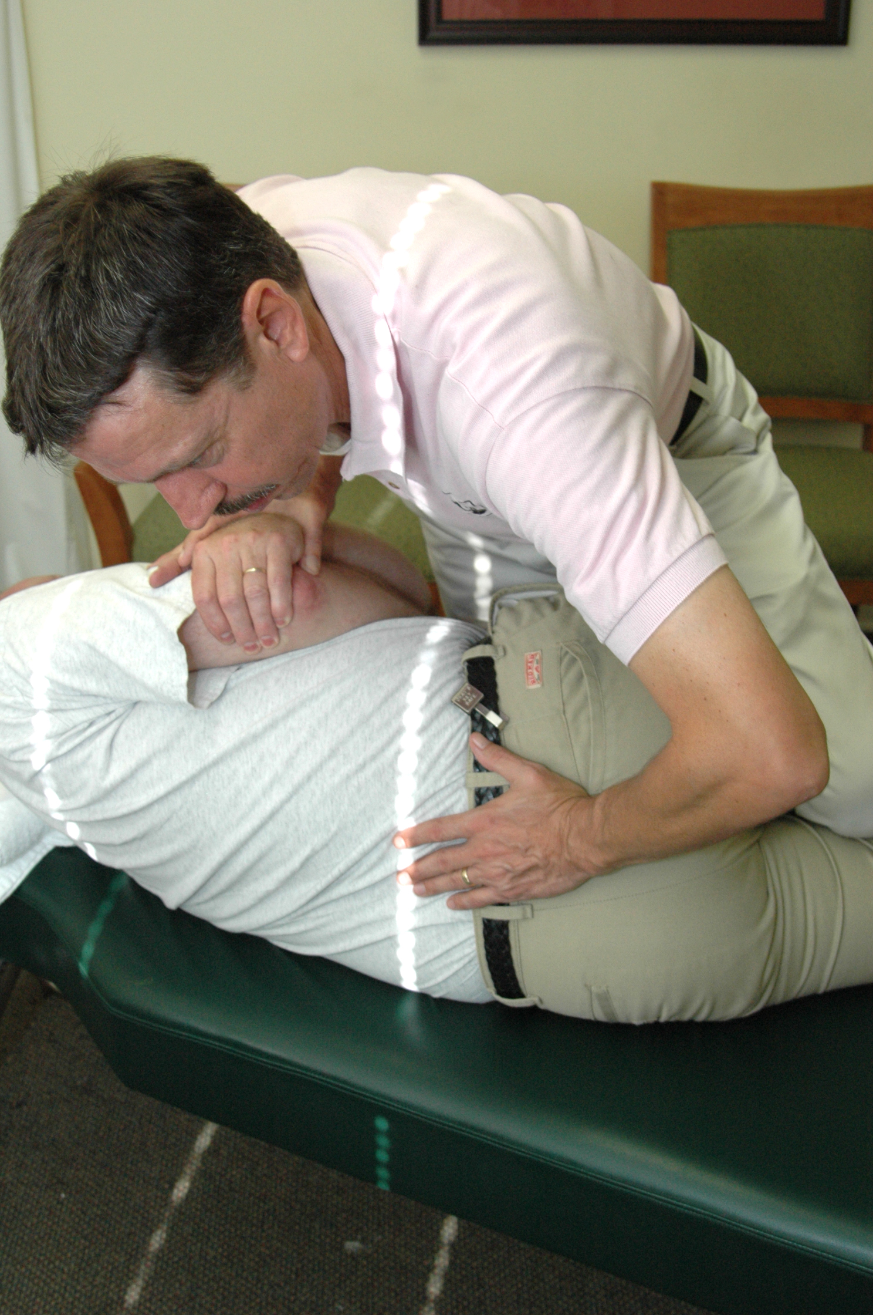
Even when you relax for the adjustment, about 4 of 10 new patients experience mild soreness that may last for up to 48 hours after the treatment. However, if you tighten your muscles and do not relax, or if you are scared by the “popping” noise and tighten your muscles while the doctor is performing the adjustment, then there may be some mild temporary pain from the adjustment itself.

Most patients can relax adequately to get a good “pain free” adjustment, but if the doctor suspects you are not relaxing enough he will tell you so. In the unusual event that you have some mild, temporary pain from your first few adjustments usually an ice pack used 2 to 4 times per day will totally alleviate this complication. Call the doctor if this complication persists past 24 hours, or if you experience any other problems.

So remember, for best results the most important thing for you to do is to relax! Keep in mind that when you hear popping sounds that this is good news, because less pain, new circulation, improved range of motion and possibly realignment of the joints will now be able to occur.

The Federal government determined that spinal manipulation is “safe and effective,” for acute and chronic neck and low back pain, neck tension and migraine headaches [US Agency for Healthcare Research & Quality]. So relax and get the best possible adjustment!

©2020 by Robert A. Leach

